

Southwestern Elementary School Parent-Teacher Association (PTA)
09-26-2023
Southwestern Elementary School
General Membership Meeting
Presiding: Lori Mounie, Principal & Leslie Brennan, President
6:00 pm – 7:00 pm
Attendance

PTA Board:
Leslie Brennan - President
Dee Lewis – Vice President
Becky Adams - Treasurer
Megan Waltrip – Secretary

Southwestern Administrators:
Lori Mounie – Principal at SWES
Dr. Sabrina Lee – Vice Principal at SWES
Jennifer Soriano – Academic Coach
Mrs. Littlefield – Title 1 Administrator

All Southwestern Teachers were in Attendance

Active PTA Members in Attendance: 13 (20 including board members & SWES Admin)

Treasurer’s Report
- The PTA Treasurer’s Report indicated a cash balance of $91.98 as of September 26, 2023
- Complete Treasurer’s Report and 23/24 Budget Attached

Agenda
- Sign in with distribution of physical PTA cards and printed meeting documents
- Introductions of Board Members
- Review previous minutes
- 23/24 Proposed Budget, Bylaws, & Standing Rules
- Vote Discussed Items
- New Items: Title 1 & STEM Future Events, Task Force List and Important Links

Upcoming Meeting Dates
See attached documents for all upcoming plans

Summary
Prior to General Meeting one email on 9/24/23 and a follow up email on 9/26/23 were sent to all active PTA members via MemberHub/GiveBacks with a request for members to review the following important attachments and reach out with questions, concerns, input, etc:
- Uniform Bylaws
- Standing Rules
- Membership and Program Report
- Election Night PTA Minutes
- PTA Contacts List
- 22/23 PTA Audit
- September Treasurers Report
- General Meeting Summary PDF PowerPoint
At sign in, active members of the PTA were handed a physical copy of their 23/24 PTA Membership Card and a printed copy of the General Meeting Summary PDF PowerPoint which contained a printed copy of:
- Introductions of Board Members
- 23/24 Proposed Budget
- Title 1 & STEM Future Events
- Task Force List
- Important Links

Call to order: 6pm by Leslie Brennan, PTA President with Pledge of Allegiance
Attendance of active PTA members was taken: 13 (20 including board members & SWES Admin).

2023/24 Board Members were introduced and a recap of recent communications was shared (such as emails sent, documents attached).
Leslie Brennan, President, asked for a motion to accept Proposed Bylaws.
Motion to Accept by Member: Ciara Chavis
2nd by General PTA Member
In Favor: 12
Opposed: 0
Bylaws: Approved
Leslie Brennan, President, asked for a motion to accept Proprosed Standing Rules.
Motion to Accept by Renee Giddens
2nd by General PTA Member
In Favor: 12
Opposed: 0
Standing Rules: Approved
Dee Lewis, VP, briefly discussed PTA objectives, volunteer/taskforce opportunities, fundraising and membership goal of 400 by Nov 1st
Becky Adams, Treasurer, reviewed the September budget and proposed 23/24 Budget.
Leslie Brennan, President, asked for a motion to accept proposed 23/24 Budget.
Motion to Accept by Ciara Chavis
2nd by General PTA Member
In Favor: 13
Opposed: 0
23/24 Budget: Approved
Megan Waltrip, Secretary, recapped minutes from previous general meeting on 5/30/23 resulting in the nomination of current board members. Announced next general meeting will be on 11/14/23 at 6pm.
Leslie recapped:
Importance of PTA membership
Announced the upcoming 10/10/23 Chick-Fil-A Spirit Night Fundraiser
Floor was opened to all members for any questions/comments concerning old business. NONE
Floor was opened to all members for any questions/comments concerning new business. NONE

Meeting Concluded

Click attachments below for full file:

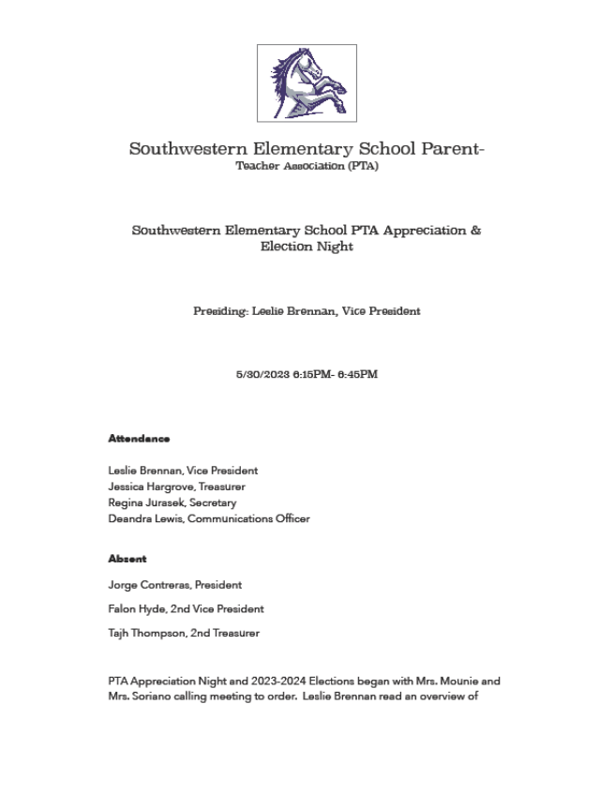
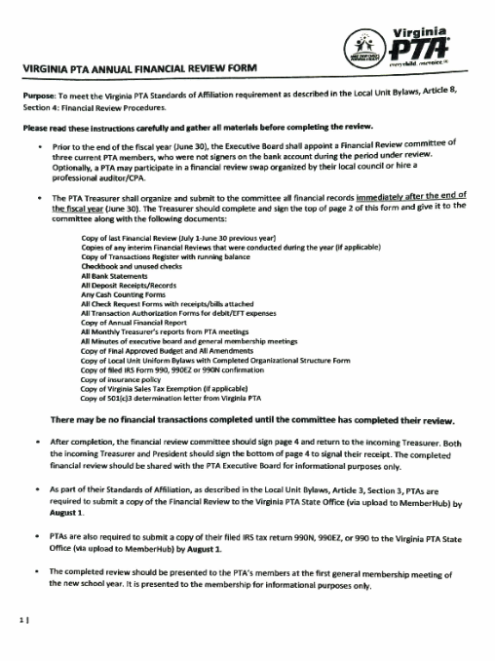

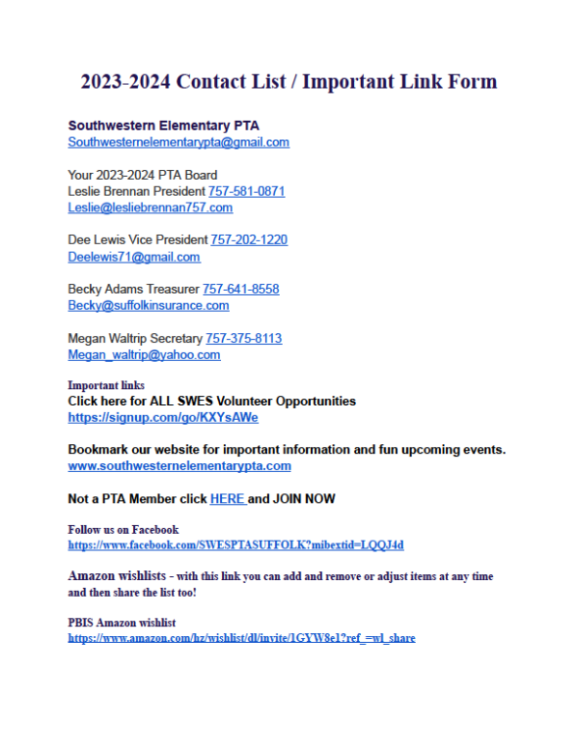
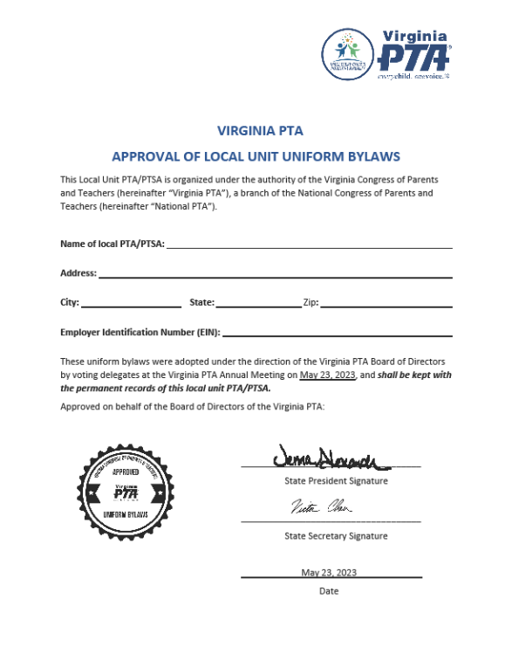

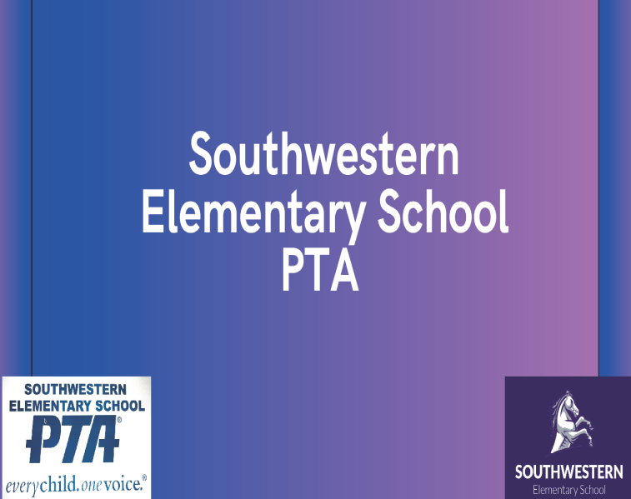

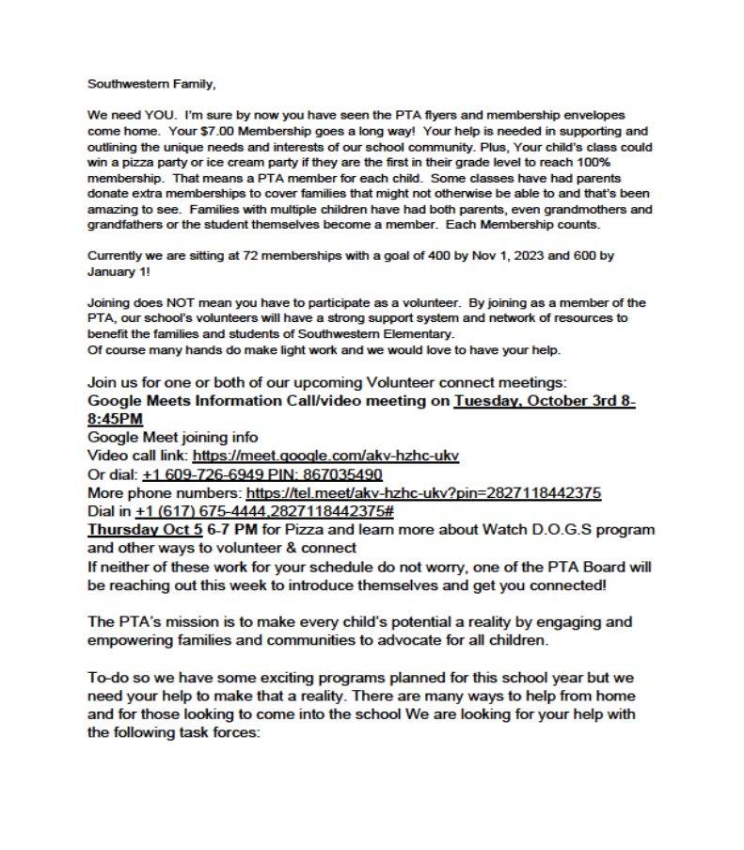

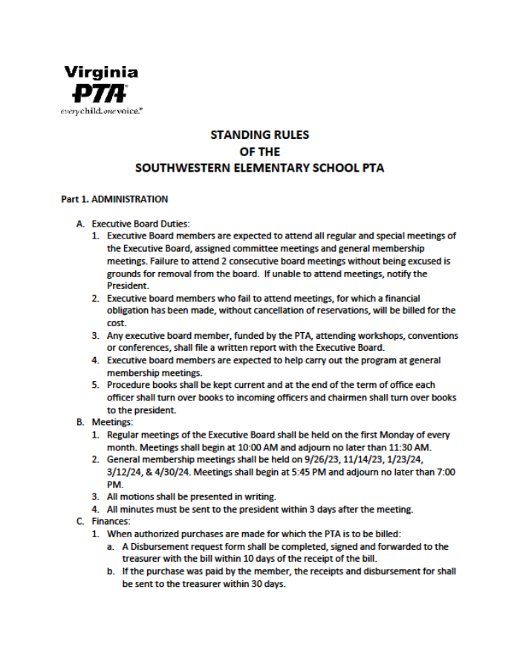

Full Treasurers Report Below:
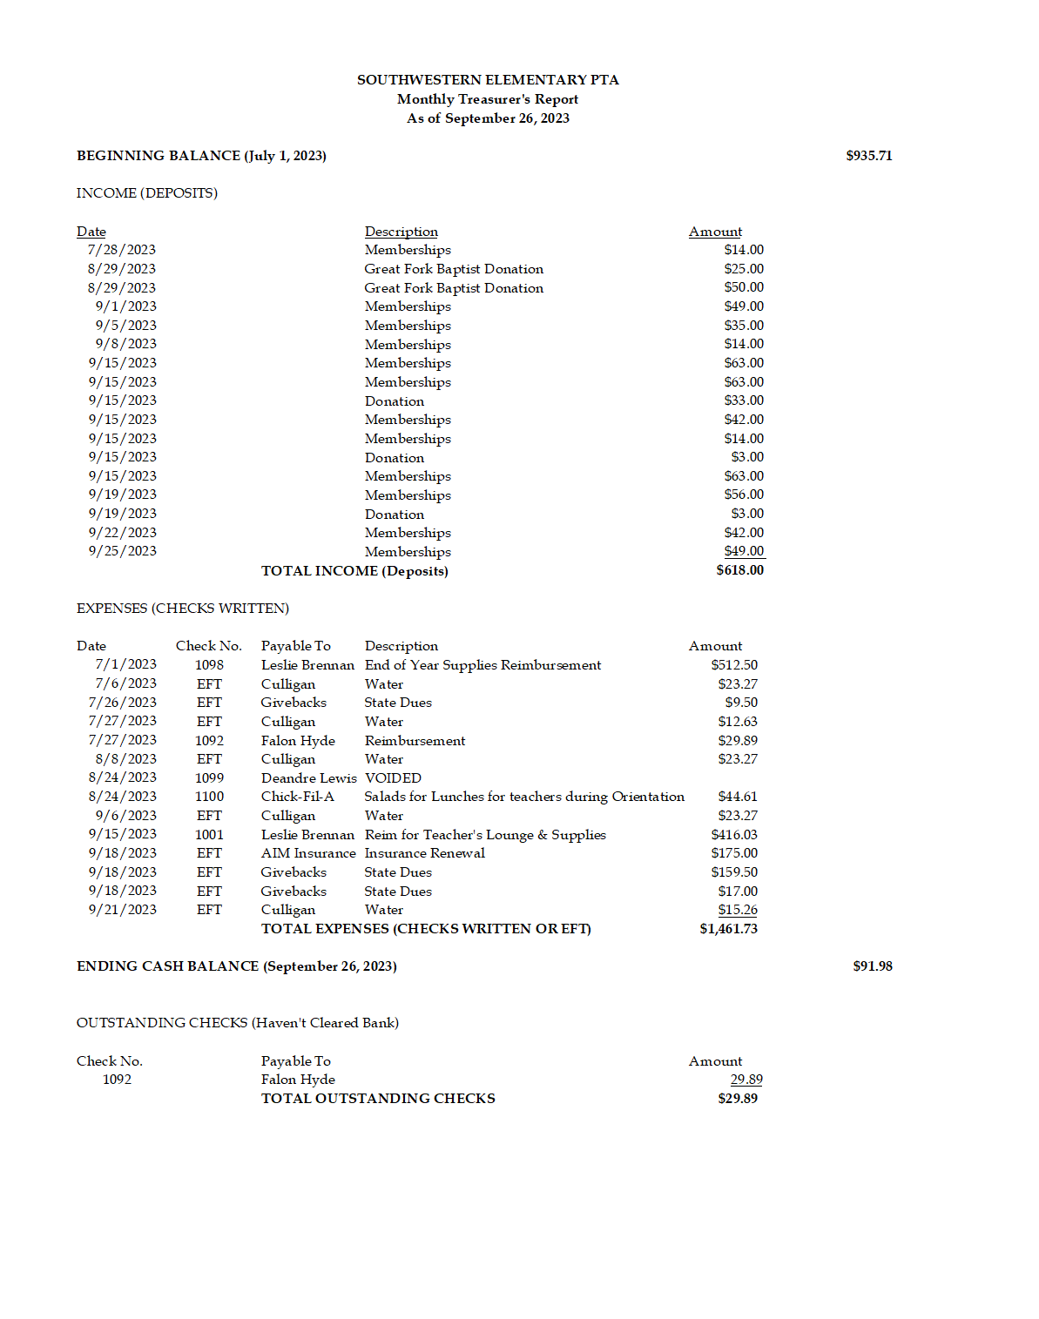FINAL PAGE.

